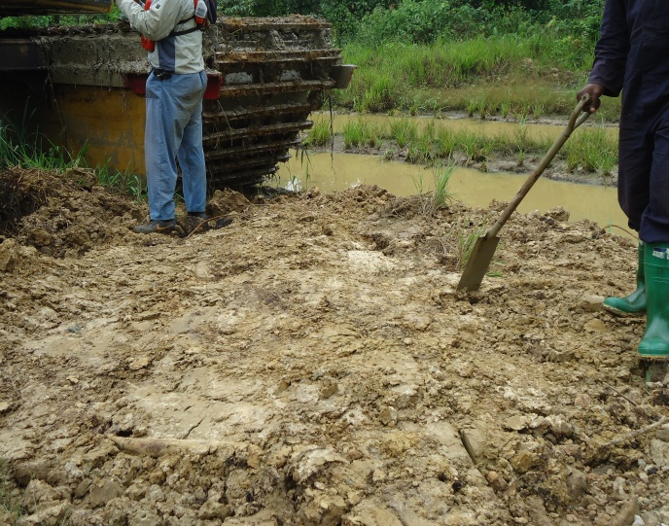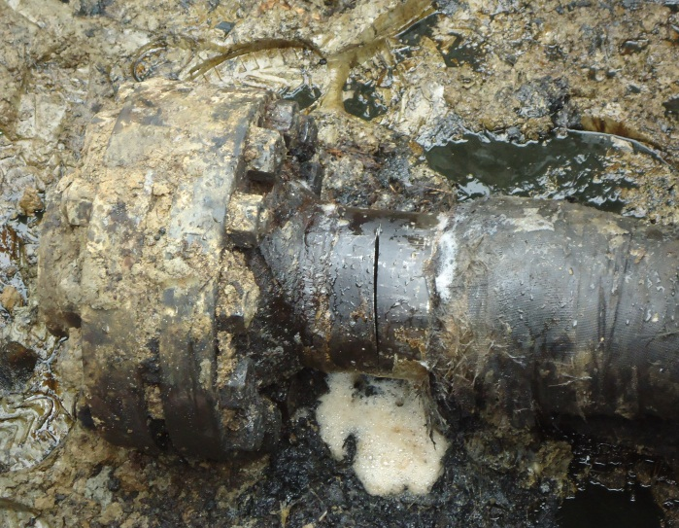
Pix showing point before excavation. Pix showing point after excavation(120mmcut)
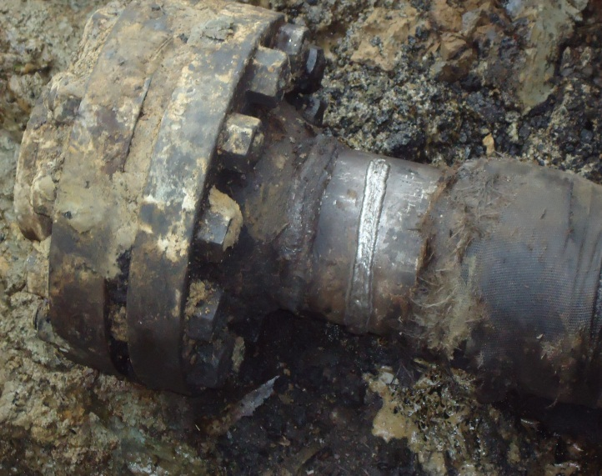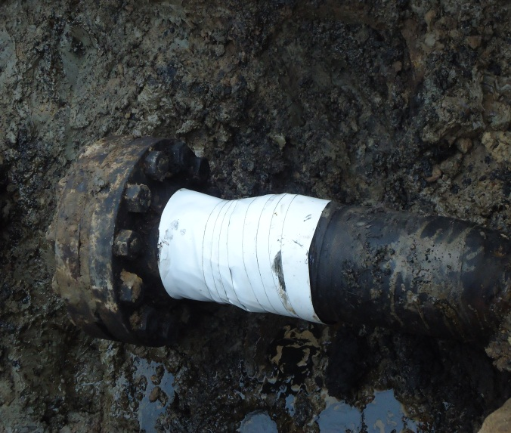
Pix showing point repaired pix showing rapping on the repaired point.
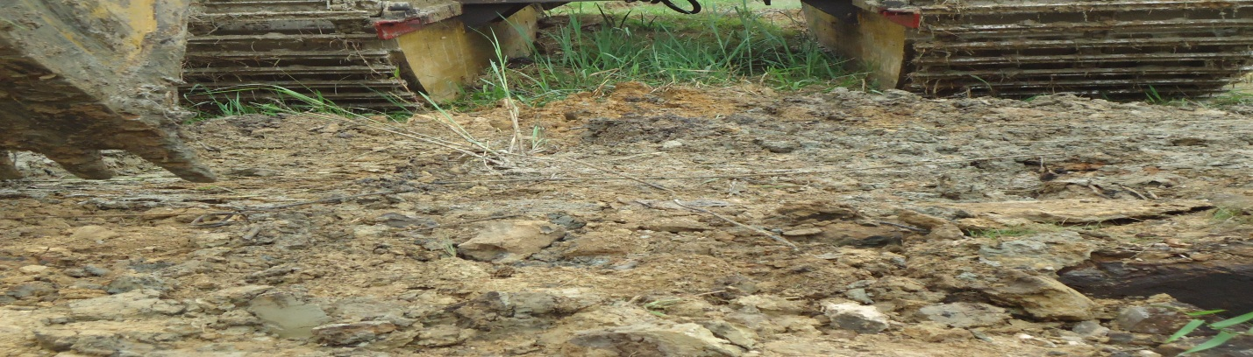
Pix showing Point backfilled after repair.

